**Roehampton Mobile App**

**Coursework 1**

The purpose of the following assignment is to design a mobile app for Roehampton University, where the students should be able to access the university Moodle page, check their timetable and the location of the areas of interest, and access the university library. Using Android Studio, we developed an Android app with the following flow chart:

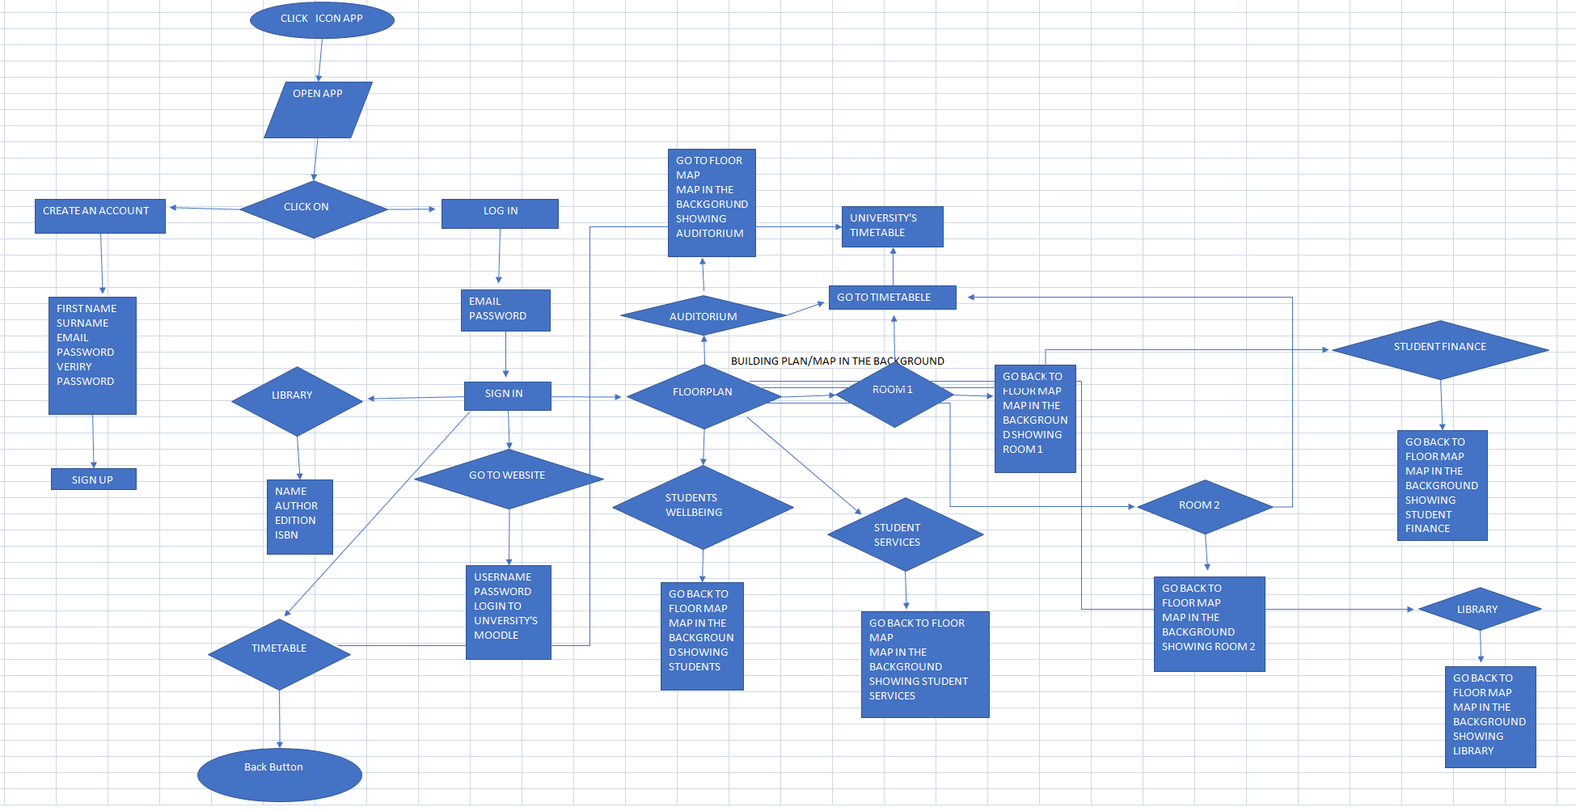

*Figure 1: App flow chart*

Once the app is launched the student can create an account in case he is a new user, log in if he already has an account, or see the video of the university. Two activities were created in order to design the first step of the app. The first activity named Welcome Activity is set to be kept on the screen for a certain amount of time (6000ms) using "splash_time_out". The action bar is hidden through "getSupportActionBar" method, and "Handler" is used to start the "Main Activity".

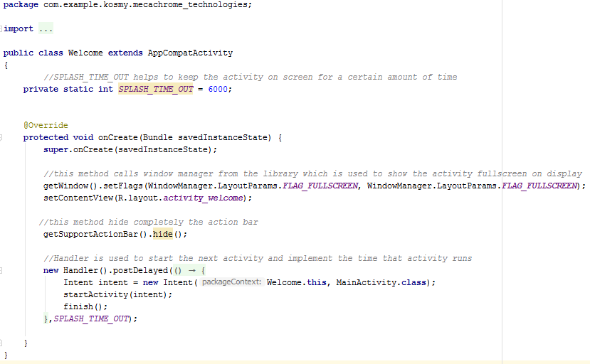

*Figure 2: Java file for Welcome activity*

For the design of this activity, we added a text file and a progress bar in the xml file.

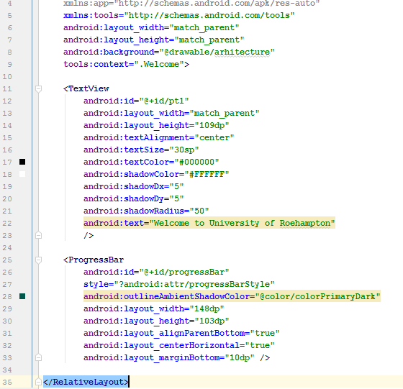

*Figure 3: XML file for Welcome Activity*

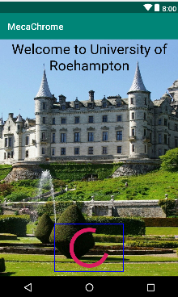

*Figure 4: Welcome activity design*

In the Main Activity three buttons are displayed: "create and account", "log in" and "see video". In java we used "intent" to set the buttons to navigate to the next activities.

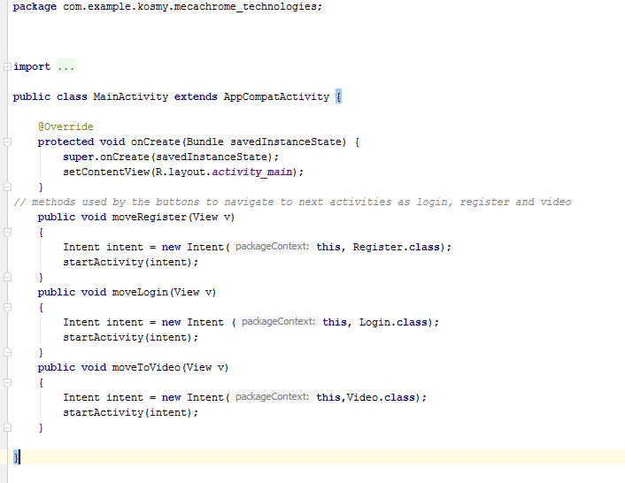

*Figure 5: Java file for Main Activity*

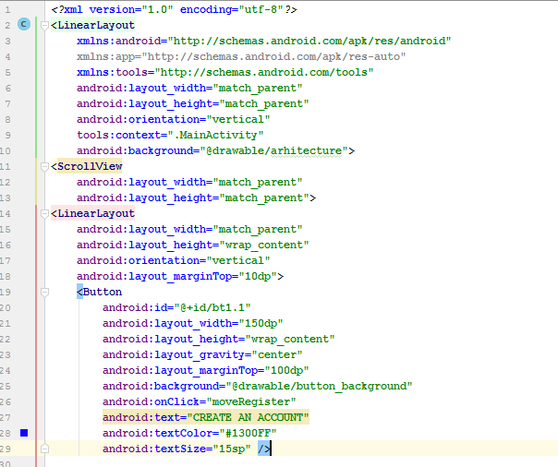

*Figure 6.1: XML file for Main Activity*

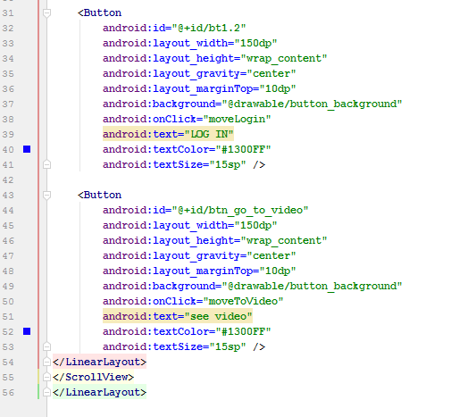

*Figure 6.2: XML file for Main Activity*

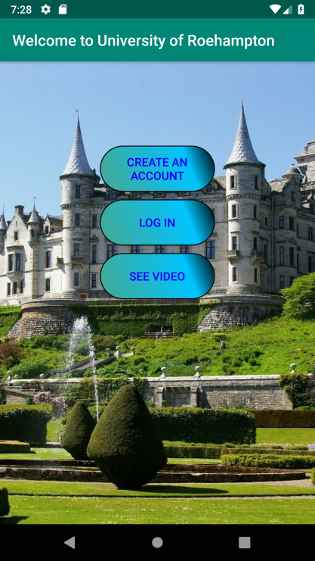

*Figure 7: Main Activity Design*

If the button "create an account" is clicked, the Register activity will be displayed on the screen and the user is asked to insert: first name, surname, e-mail address and password two times. Then the sign up button can be pressed and the sign in page will be displayed. We put if condition to check if the e-mail address inserted has been used before to create an account. If there is an account in the database on the same e-mail, the message "this e-mail is already used, try another e-mail" is returned. Also, if a field is not filled in, the following message is displayed "please fill every field above".

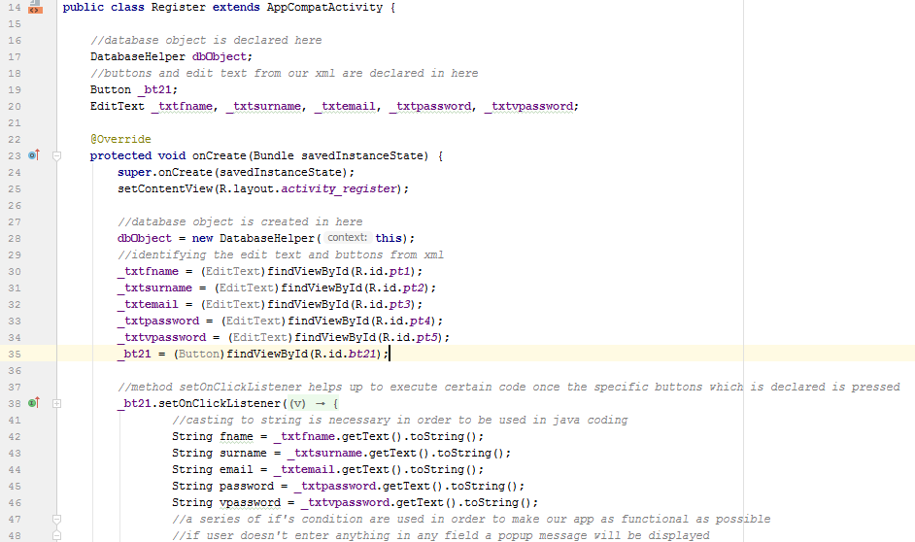

*Figure 8.1: Java file for Register Activity*

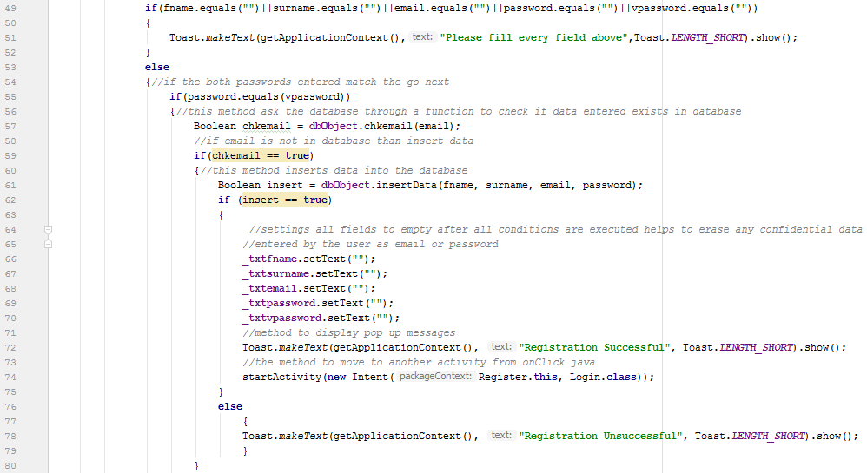

*Figure 8.2: Java file for Register Activity*

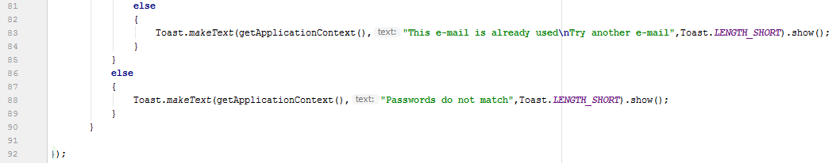

*Figure 8.3: Java file for Register Activity*

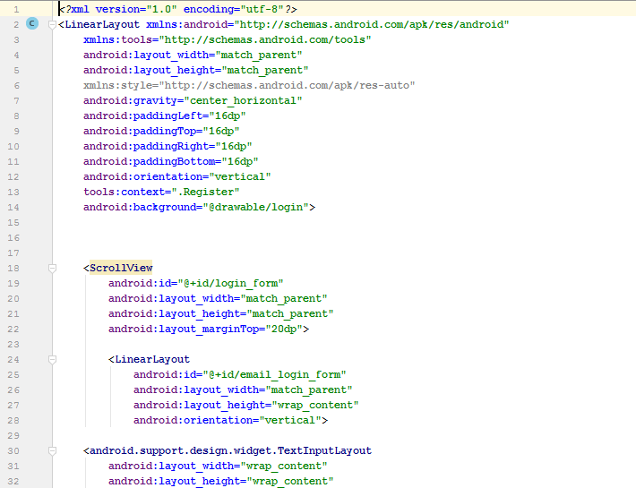

*Figure 9.1: XML for Register Activity*

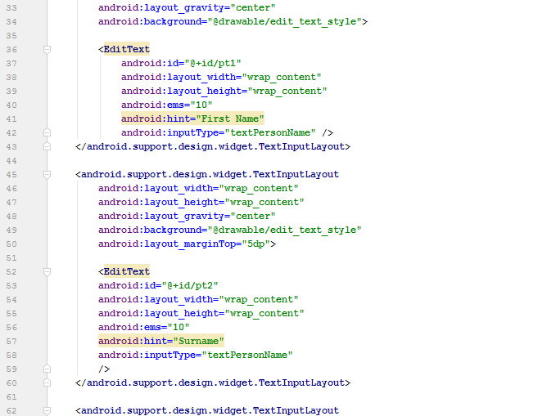

*Figure 9.2: XML for Register Activity*

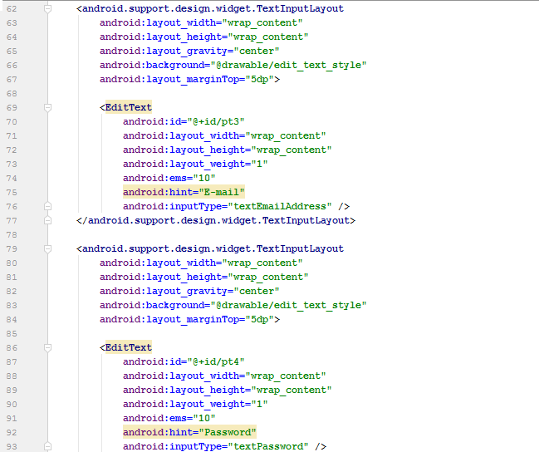

*Figure 9.3: XML for Register Activity*

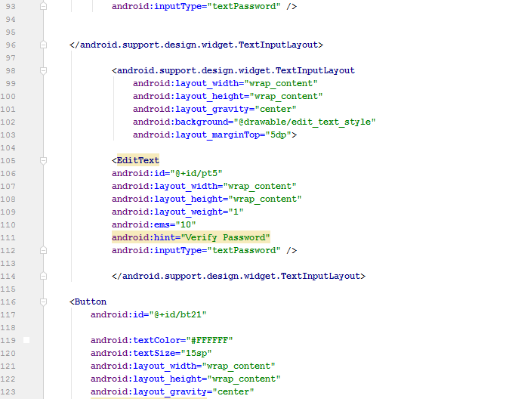

*Figure 9.4: XML for Register Activity*

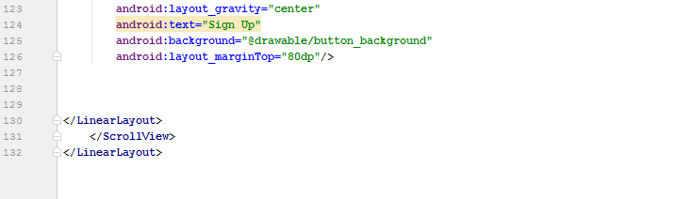

*Figure 9.5: XML for Register Activity*

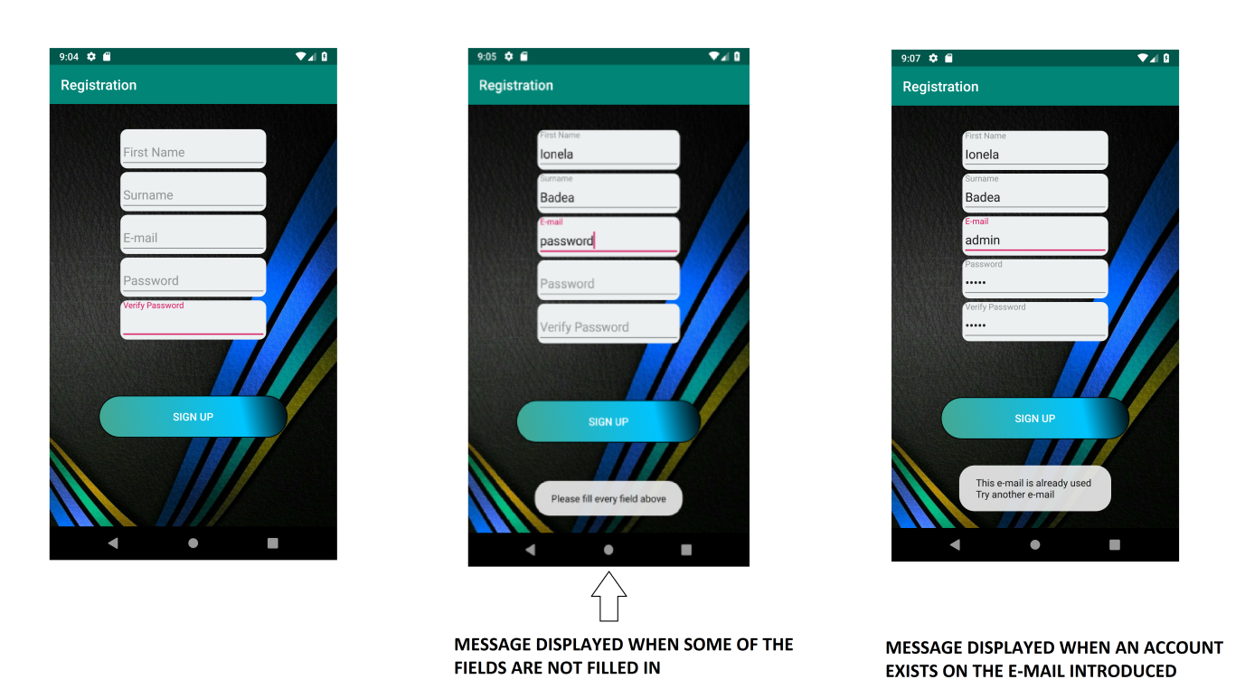

*Figure 10: Register activity design*

After the account is created, the sign in page is displayed. Here the user has to introduce e-mail and password, and press "sign in" button. In the java file for Login activity, a database object was used to check if the e-mail and password entered are correct and match any user details from the DatabaseHelper (where the users table is located). If condition was used again to return a message if one field is not completed "Please fill every field above", if the e-mail introduced does not match any of the e-mails from the database showing the message "Email is not associated to any accounts", or if the password is not correct "Password entered is wrong...Retype".

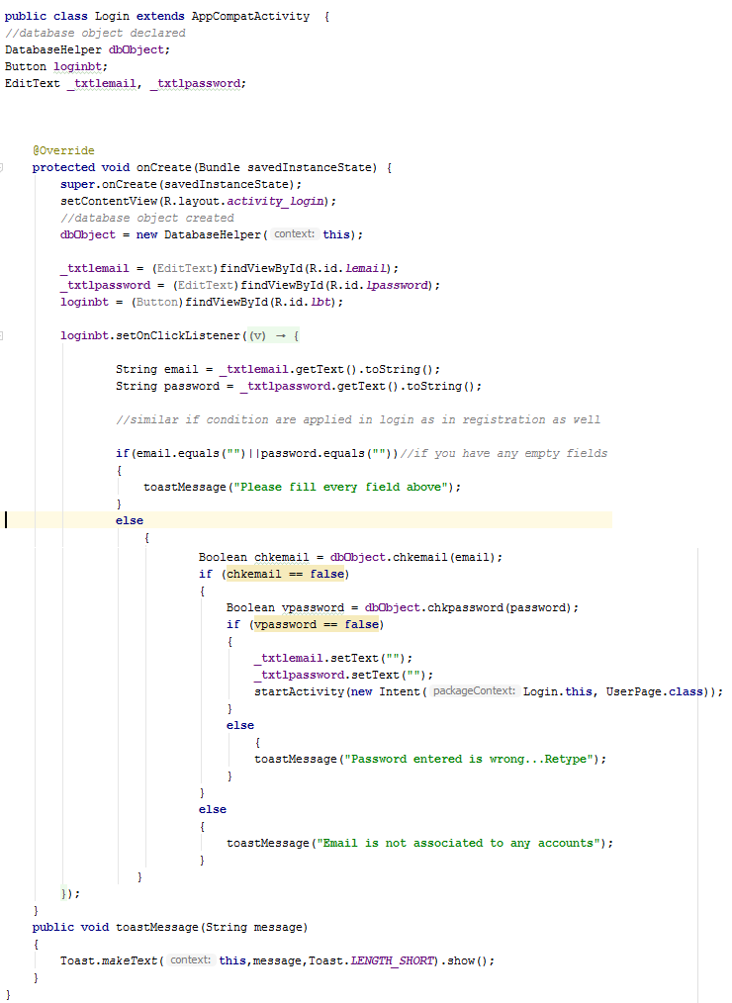

*Figure 11: Java file for Login Activity*

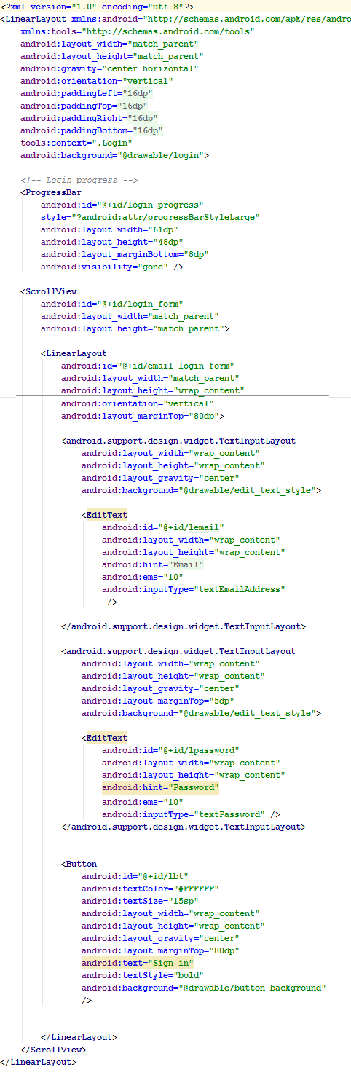

*Figure 12: XML for Login activity*

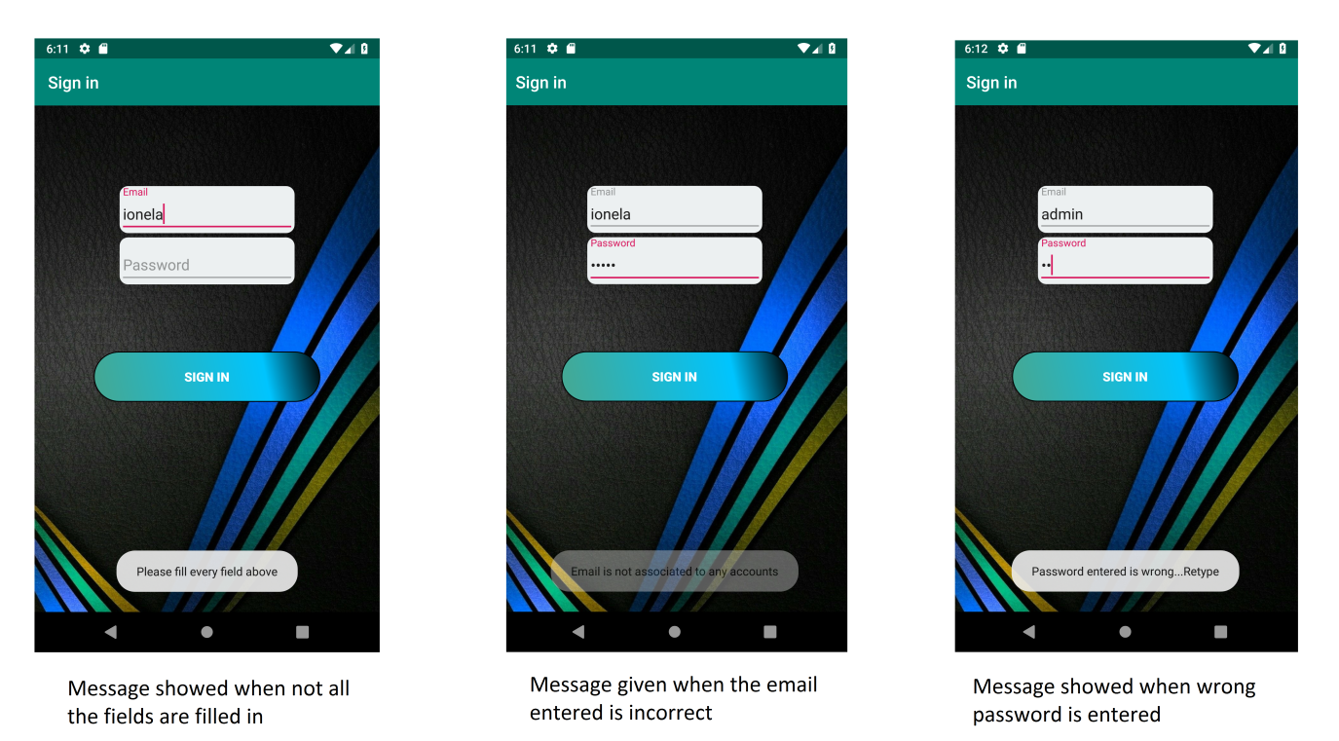

*Figure 13: Login activity design*

The last button in the Main Activity, "see video", can be clicked to watch the video representative for the University and anyone can access it, even if they have an account or not. In the java file, we have a video view and media controller is used to forward or pause the video. The uri is used to get reference of the video imported in the app, and at the end of the video, the previous activity (Main Activity) starts again. In the xml file, we only introduced the video view.

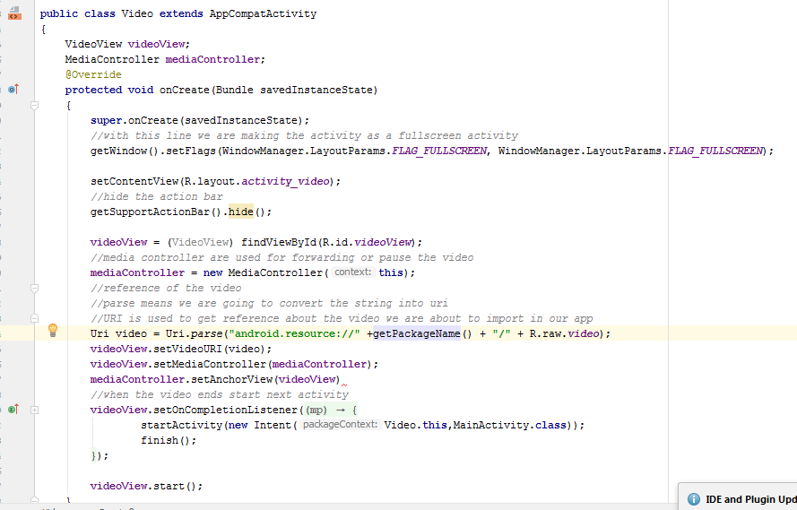

*Figure 14: Java file for Video*



*Figure 15: Design for Video activity*

Moving back to the log in page, after the details are filled in correct and the button "sign in" is pressed, the user will be introduced on the User page, where the following options are available: go to website, floor plan, library and timetable. In the java file, for each of those buttons is established what should happen when one of them is pressed. In the XML, the buttons were created and personalised.

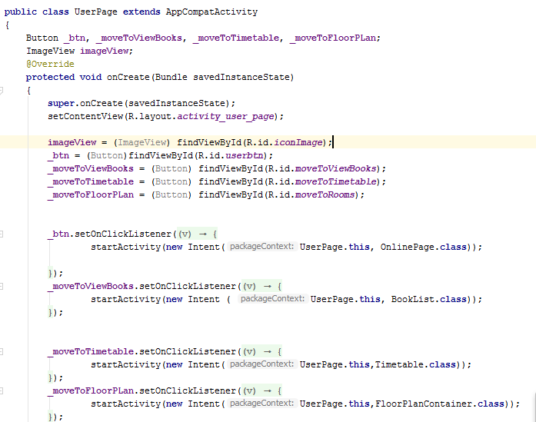

*Figure 16: Java file for user page*

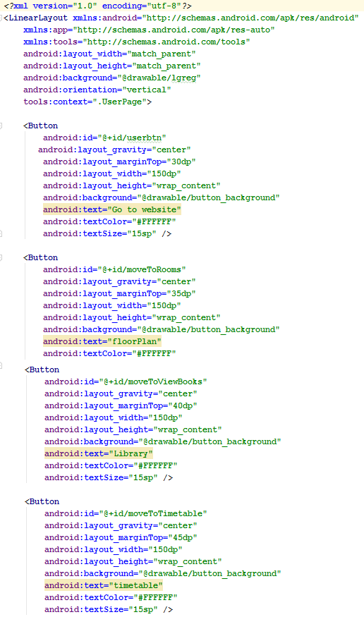

*Figure 17: XML for user page*

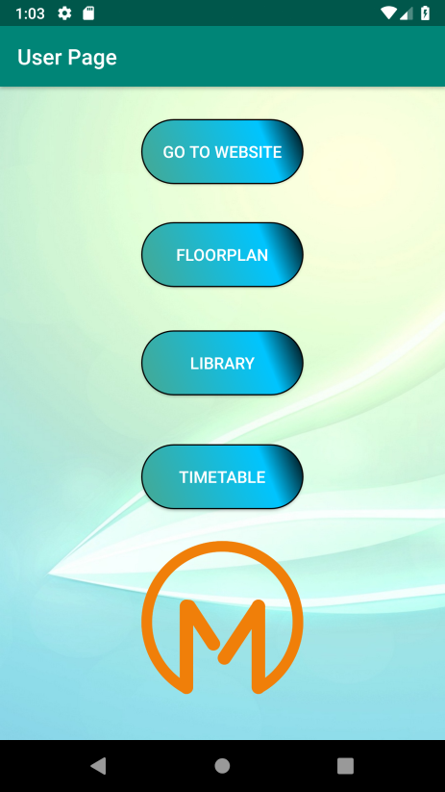

*Figure 18: Design for User page*

If the user wishes to visit the University website, he presses the first button and the moodle page is displayed. To create the Online Page activity, a web view was used where the url for the page wanted to be displayed was added. An option to go back on the user page is also available.

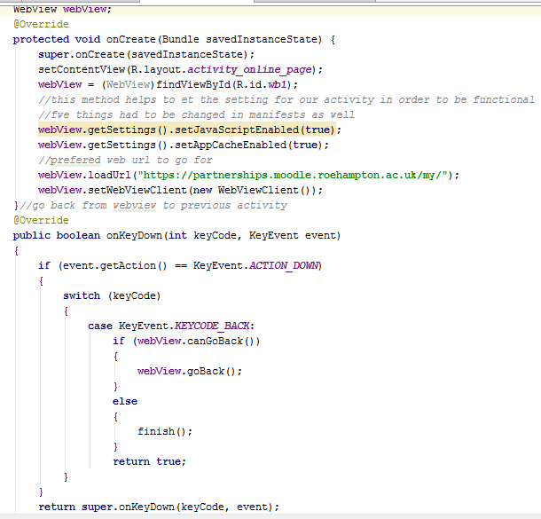

*Figure 19: Java file for Online Page activity*

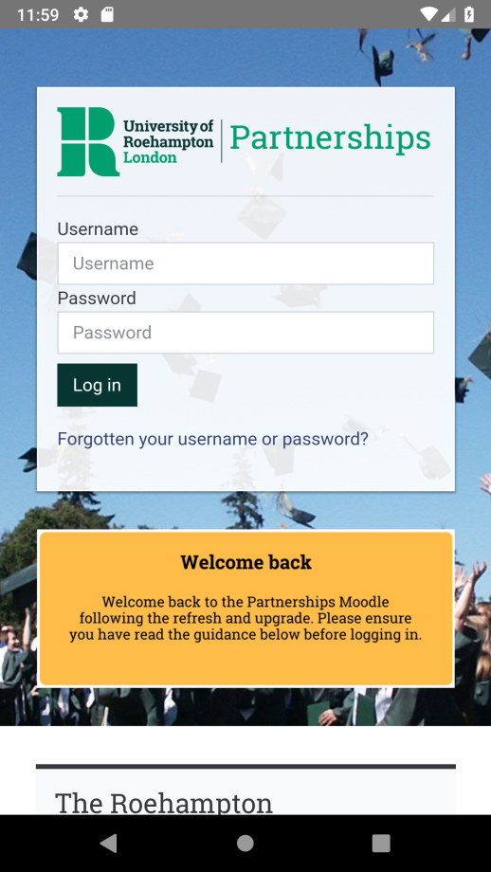

*Figure 20: Design for Online Page activity*

The page where the user can see the floor plan of the building was created using a fragment container to allow components to specify any data requirements. In this container are included all the other fragments that highlight the location of each point of interest from the university. In our java file, the first step to create this container consists of declaring the TAG within the public class created "FloorPlanContainer". Then we identify the view pager from the xml and set it up to our list order. The next step will be to declare the position of each fragment in the array and after we set the adapter to our list. In the floor plan page, the user can see the general floor plan for the university including all the areas of interest, but he also has buttons that correspond to each of the areas and if he presses one of them, the exact location of the room is highlighted.

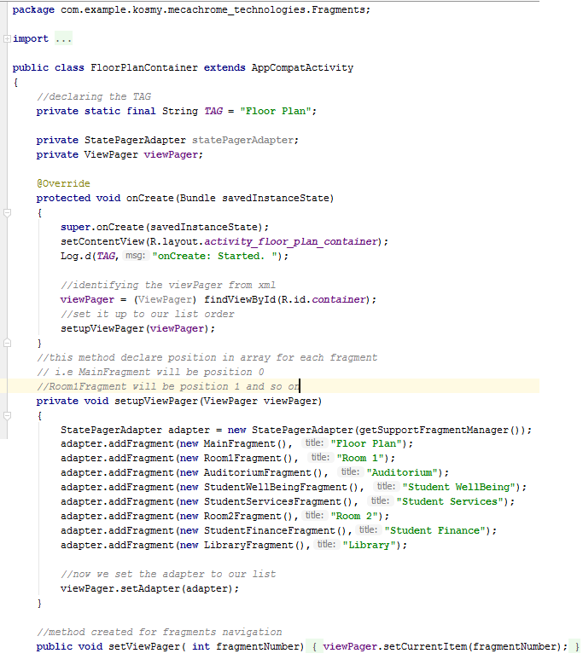

*Figure 21: Java file for Floor Plan Container*

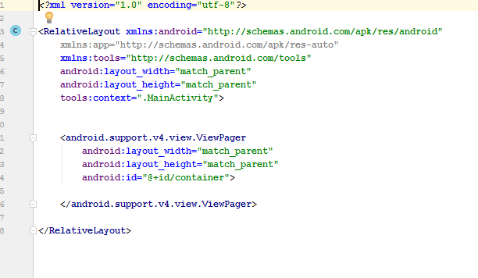

*Figure 22: XML file for Floor Plan Container*

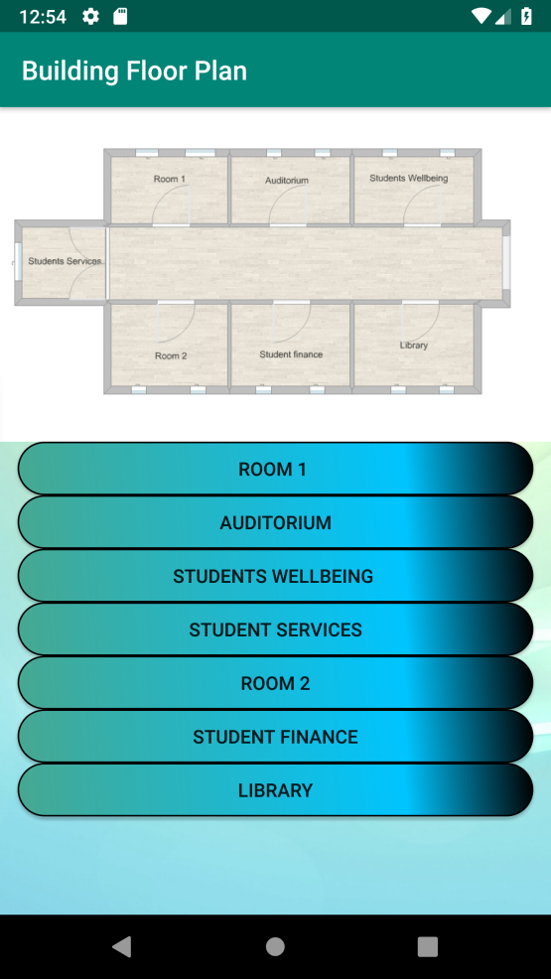

*Figure 23: Design for Floor Plan Container*

From our first plan, we can either click on each button to access the fragments were each room is highlighted, or we can return to the User page. The fragments created corresponding to each point of interest are the following: Auditorium, Library, Room 1, Room 2, Student Finance, Student Services and Student Wellbeing. The "StatePagerAdapter" is the adapter of all fragments. In its java file, two arrays were created to keep the number and the title of the fragments. Than each of the fragments is added to the fragment list.

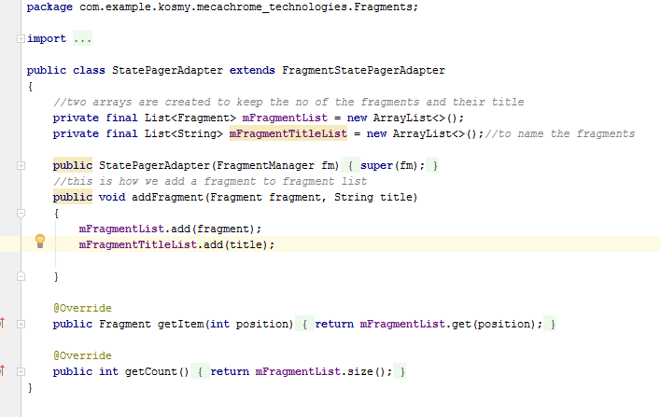

*Figure 24: Java file for StatePagerAdapter*

For the fragments created, the java file is similar. The only difference consists of the buttons assigned and the images they are linked to. In the beginning of the java file, the buttons are declared, than an override method is created in order to inflate the fragments into view pager. The inflate method is than applied. The LayoutInflater is used to initiate the XML file in its view objects. Afterwards, we identify the id of the buttons. A specific method is used to navigate through the fragments: the container is accessed and we get the fragment position where we want to navigate. In the XML files of each of the fragments, an image view was added to see the plan with the rooms, and two buttons that allow the user to go back to the main floor plan, or to the timetable where is the case (for Room 1, Room 2 and Auditorium). The xml files and the designs are also similar, but each of the fragments highlights a different room of the University.

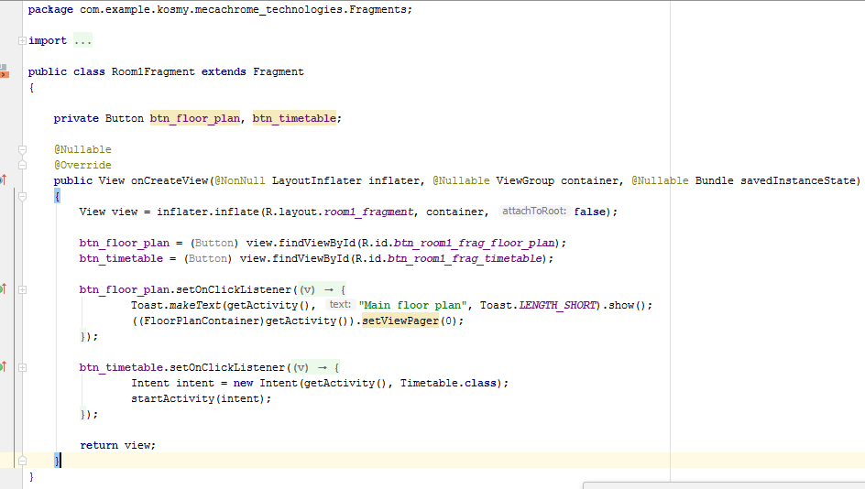

*Figure 25.1: Java file for Room1 Fragment*

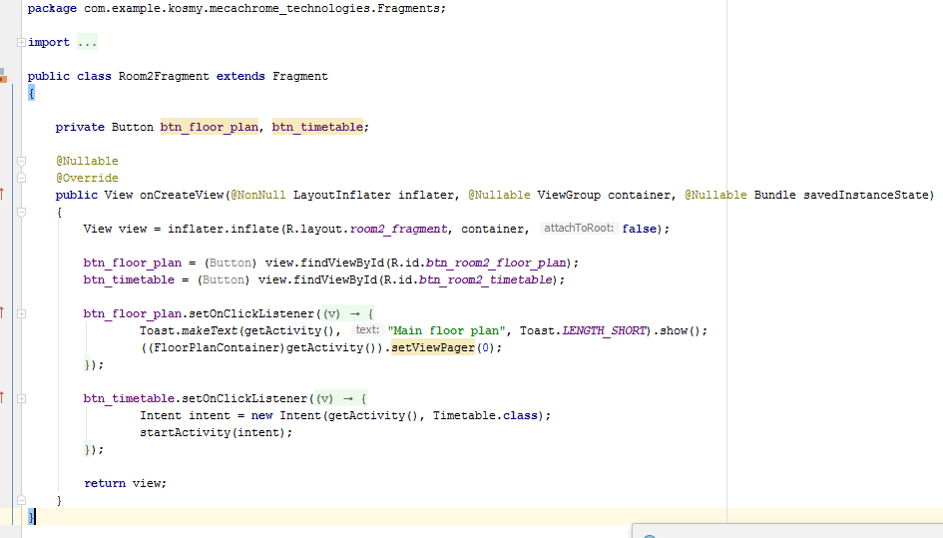

*Figure 25.2: Java file for Room2 Fragment*

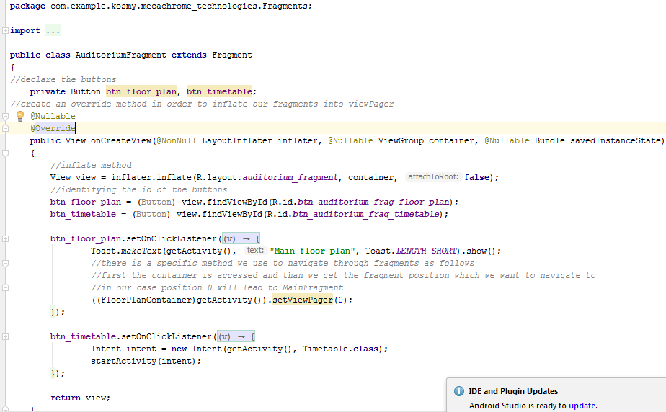

*Figure 25.3: Java file for Auditorium Fragment*

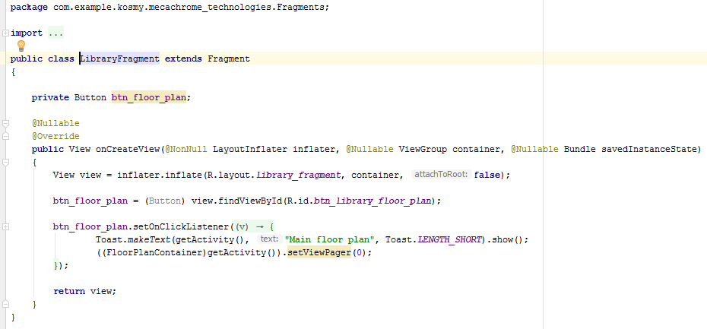

*Figure 25.4: Java file for Library Fragment*

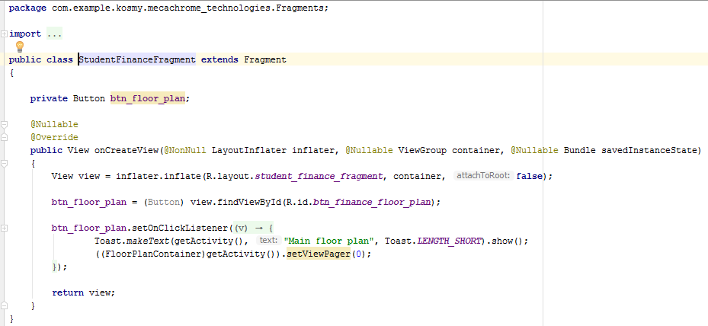

*Figure 25.5: Java file for Student Finance Fragment*

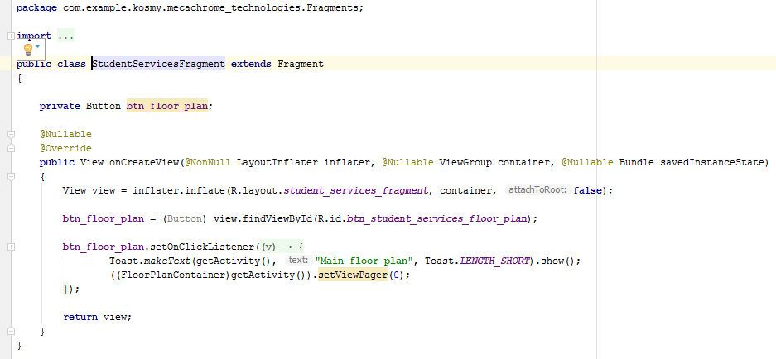

*Figure 25.6: Java file for Student Services Fragment*

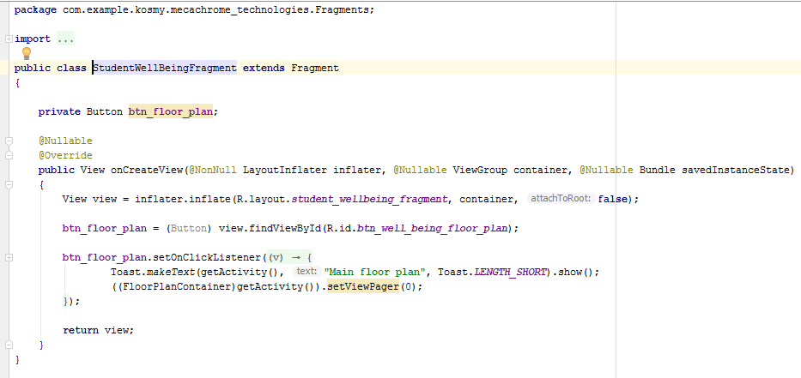

*Figure 25.7: Java file for Student Wellbeing Fragment*

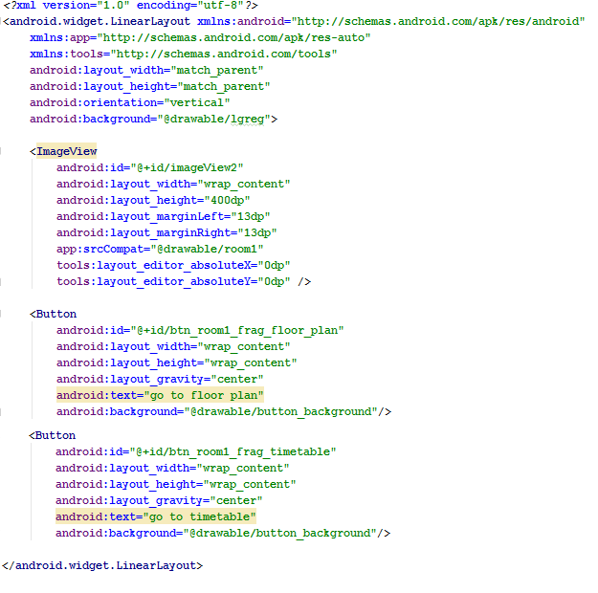

*Figure 26: XML file for Room1 Fragment*

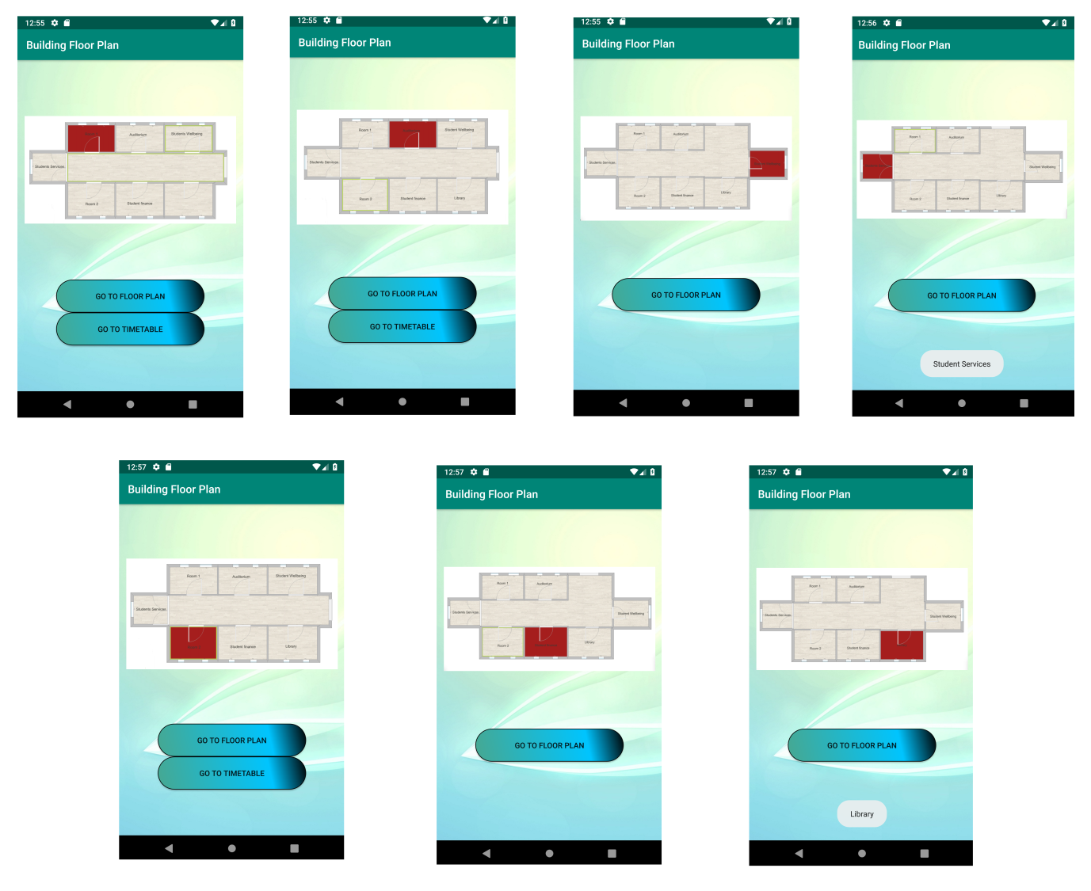

*Figure 27: Design of the Fragments created to highlight each room*

As mentioned above, the timetable can be accessed from Room1, Room 2 and Auditorium Pages, but also it can be accessed from the User page. Here the users can see when and where the university lectures are taking place. Also, behind each lecture is a button that the user can click on in order to see the location of the class room. In the java file we used "intent" to start the activities behind the buttons. The xml files are more complex, containing the table design and the buttons as well.

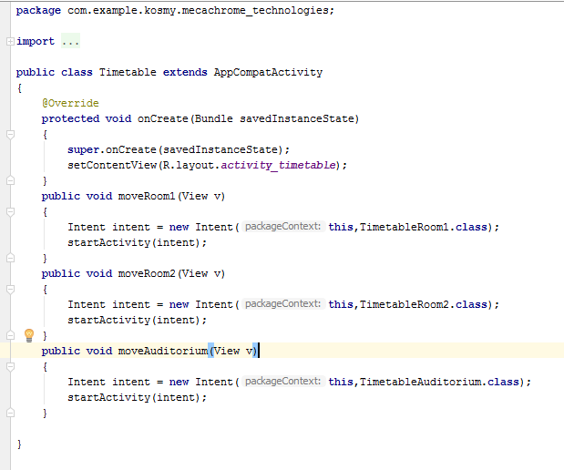

*Figure 28: Java file for Timetable Activity*

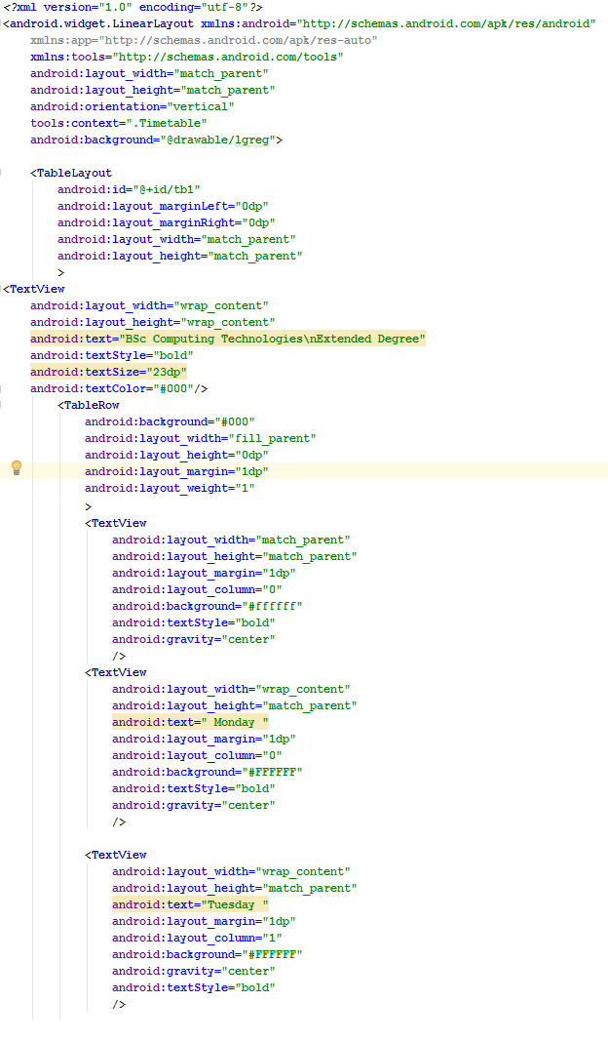

*Figure 29.1: XML file for Timetable Activity*

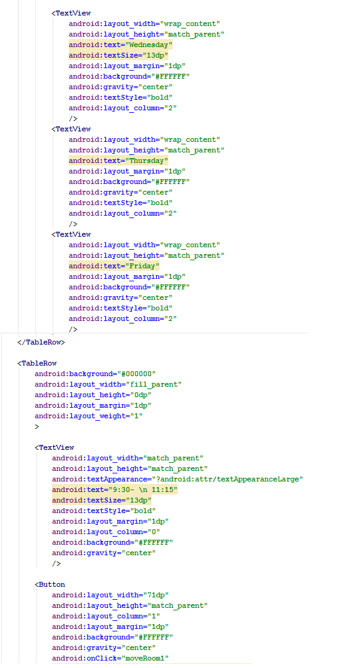

*Figure 29.2: XML file for Timetable Activity*

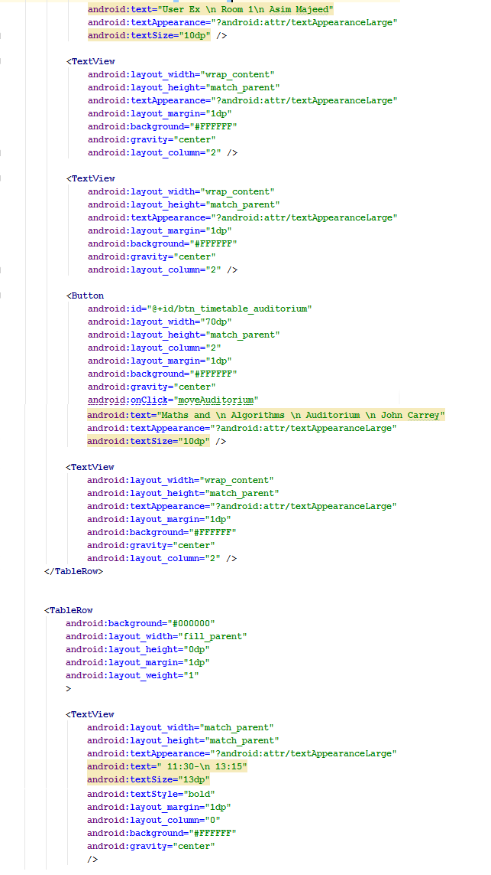

*Figure 29.3: XML file for Timetable Activity*

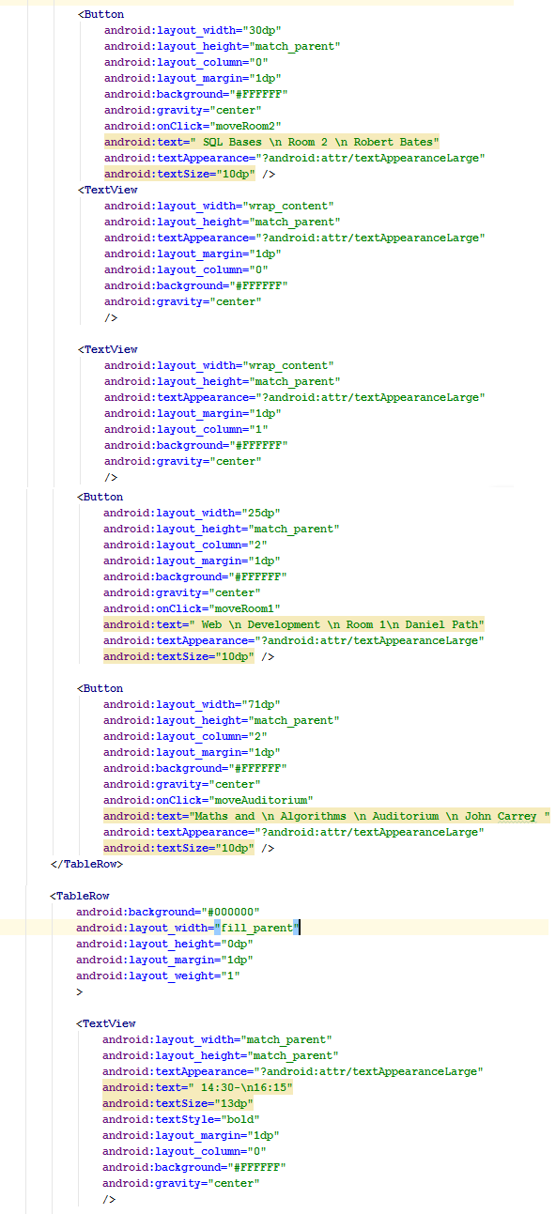

*Figure 29.4: XML file for Timetable Activity*

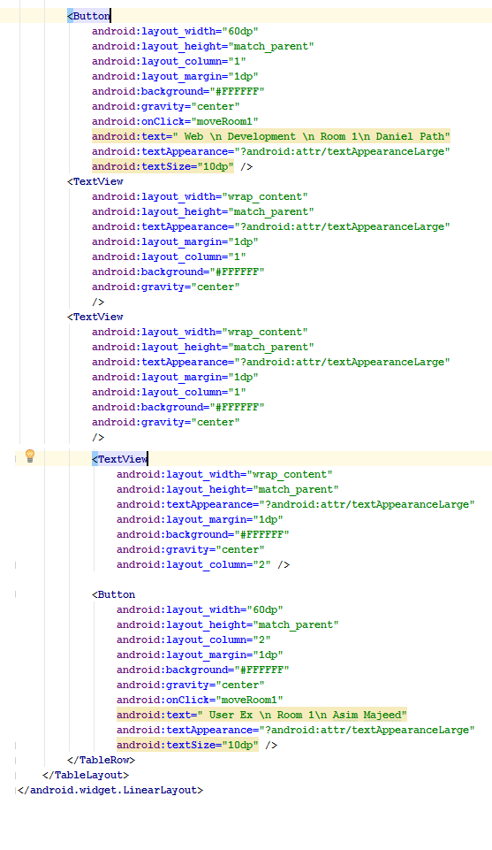

*Figure 29.5: XML file for Timetable Activity*

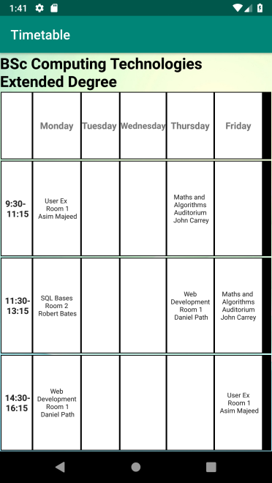

*Figure 30: Design of Timetable activity*

The last page to be accessed from the user page is the Library which contains another 5 classes: BookList, BookAdapter, BookDatabase and BookModel.

**BookList**

In assignment we must display the book from Database in a” gridView”, which is incapable of displaying any data on its own. We have used the “gridView” because it is a type of widget that can display millions of items without any lag while keeping memory and CPU usage very low. To display the data from Database on the “gridView”, the following procedures have to be implemented. Firstly, we declare the “gridView” object and “Array List” object which takes in BooksModel class, the custom “Adapter “object and the Database object. In the onCreate method, we identified the gridView from the XML layout, create objects for Database and Array List. “LoaddataInView” function is initialised in “onCreate” method but is created outside its boundaries and it contains the following steps: list object accesses the “getData” function from the data base, the custom Adapter is created and takes in our List object, on our gridView the custom Adapter it’s been set.

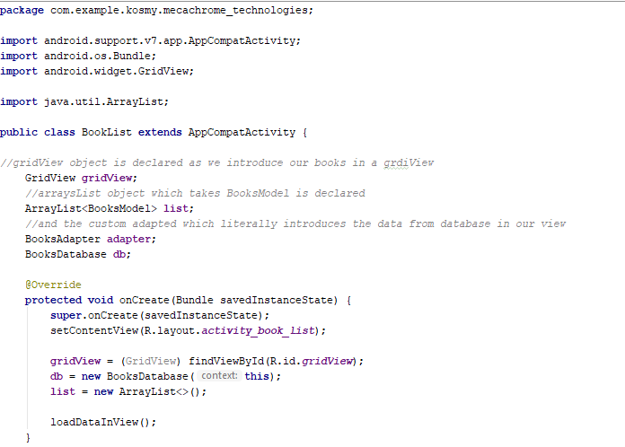

*Figure 31.1: Java file for BookList class*

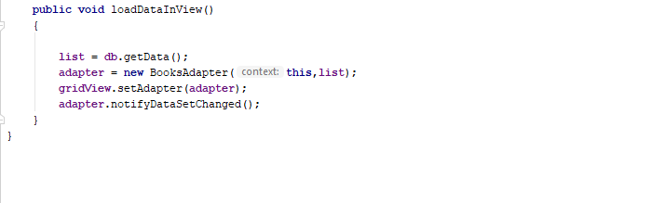

*Figure 31.2: Java file for BookList class*

In order to have a good looking design displaying the data into the gridView, a custom Layout XML file is created, as shown in Fig. 32 . All the data will be displayed in an “image view”, four “textViews” are created, and another four “textViews” are used to display the name of the data, such as NAME, AUTHOR, EDITION and ISBN. These will be shown permanently on the screen and will not be changed at any time, so the user will know what is displayed. For example, for “NAME” the name of the book will be displayed. BookList XML file is used as a “container” for our custom layout and here the custom layout will be inflated and displayed on multiple rows.

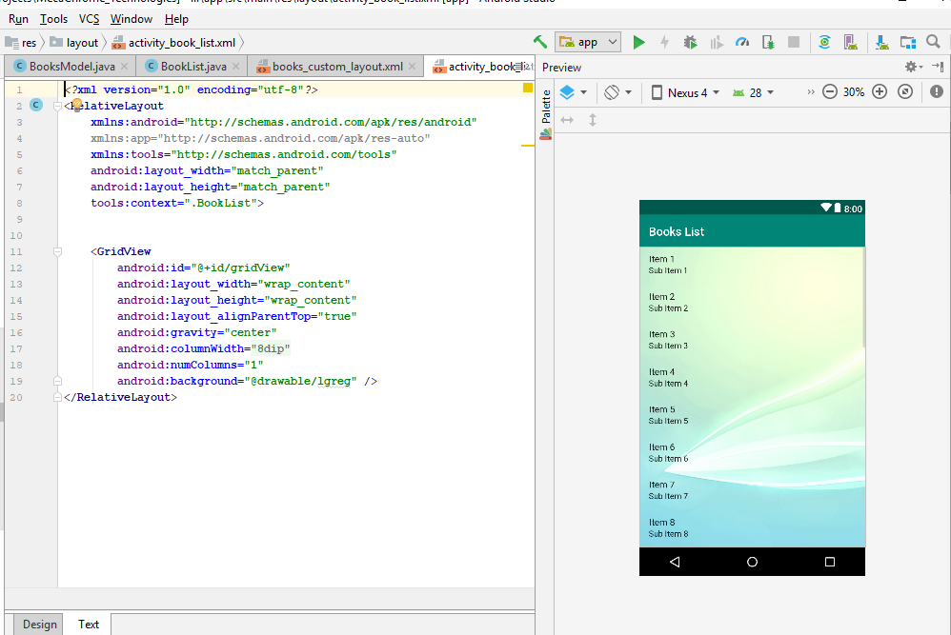

*Figure 32: XML gridView*

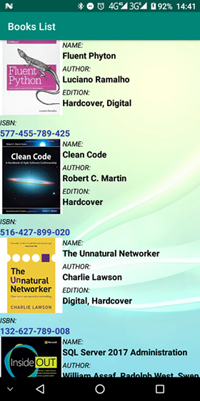

*Figure 33.1: Design for BookList class*

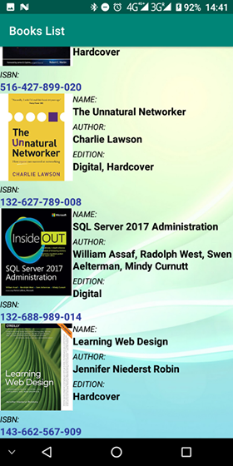

*Figure 33.2: Design for BookList class*

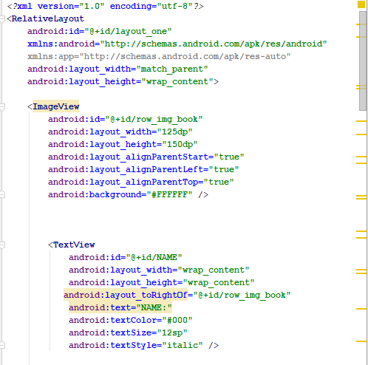

*Figure 34.1: XML for BookList*

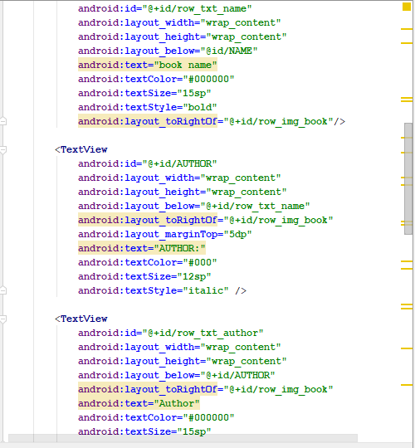

*Figure 34.2: XML for BookList*

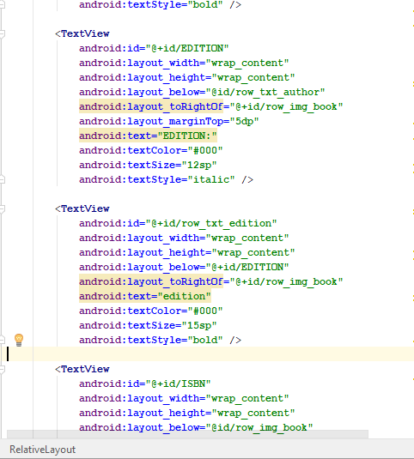

*Figure 34.3: XML for BookList*

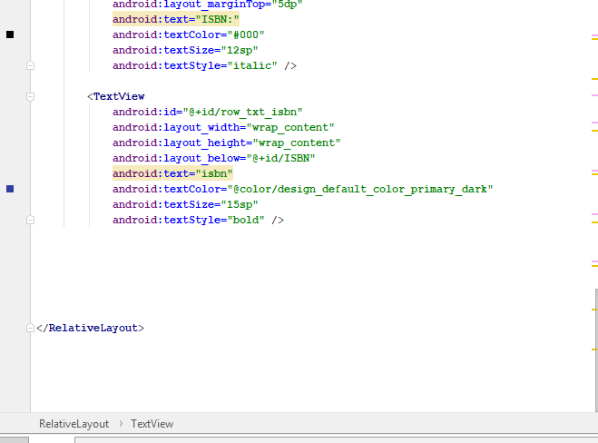

*Figure 34.4: XML for BookList*

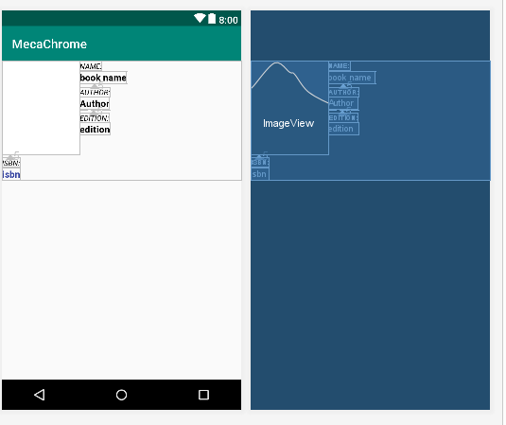

*Figure 35: XML for Custom Layout*

**BookModel**

To inflate the data into our “griview”, an adapter should be created. This is the class called “BookAdapter”, responsible for retrieving the data from a Data Set which in our case is the class called “BookModel”. In this class the variables are declared, and a constructor is created to take in all the variables declared above. After this, we need to import “getter” and “setter” methods which are used to set the data and are taken in Array List and used in “BooksAdapter” class.

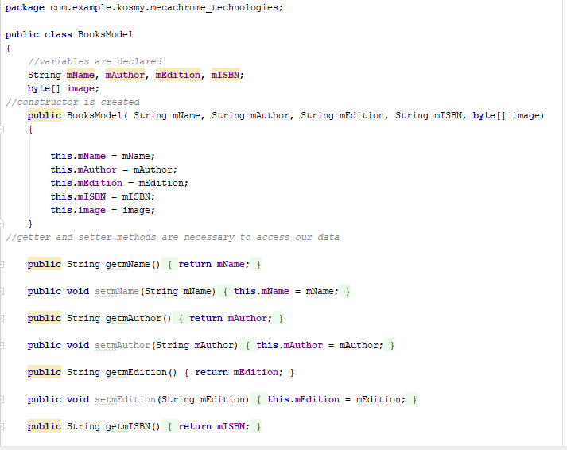

*Figure 36.1: Java file for BookModel*

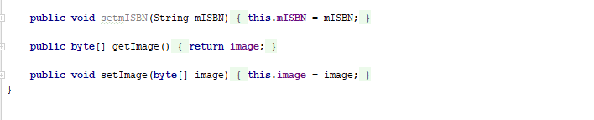

*Figure 36.2: Java file for BookModel*

**BookAdaper**

In the Custom adapter, we first declared an object for Context and another object for Array List which takes in our Data Set known as “BooksModel”. Than a constructor was created to take in the object declared above as in fig. 37.

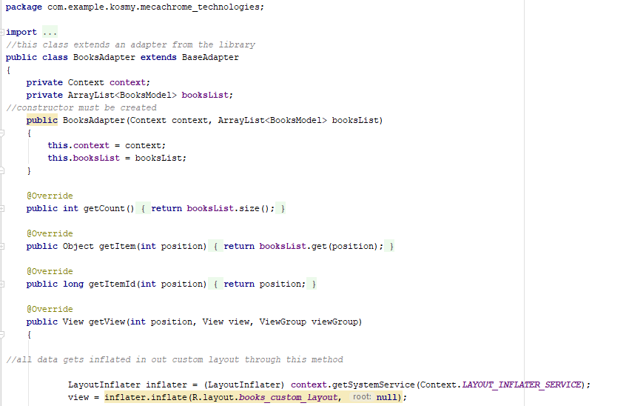

*Figure 37.1: Java file for BookAdapter*

Further, we created an “OverRide” method called “GetView”. With this method we can inflate our data into the GridView.

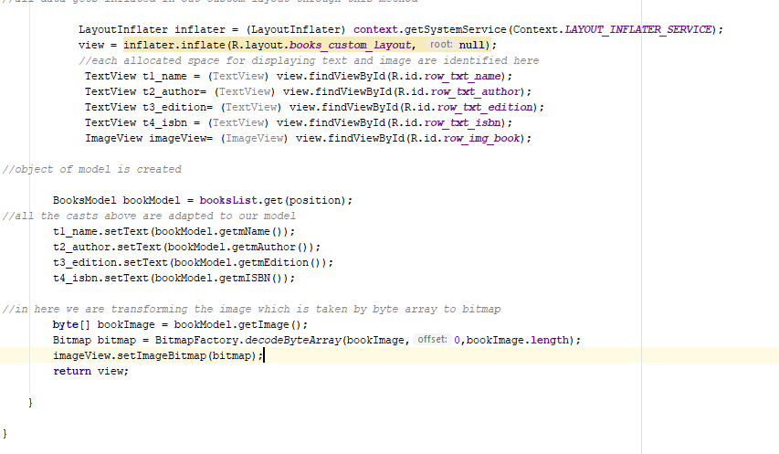

*Figure 37.2: Java file for BookAdapter*

Layout is called from the Library which instantiate our custom layout XML file into its corresponding view objects. The following step is to identify the TextViews from XML file in order to let know Java on what needs to work on. In the XML file we have an image view as well, declared as “imageView”. The following action happens in our getView method too, as we create an object for our BooksModel class. Here we must set our TextViews to each our “getter” from BooksModel class, and for imageView we used a byte array to convert the image from its primitive type to a Bitmap in order to store it in our Datbase.

The BooksDatabase class is similar to DatabaseHelper class which is used to store the users, but this class is storing the books info.

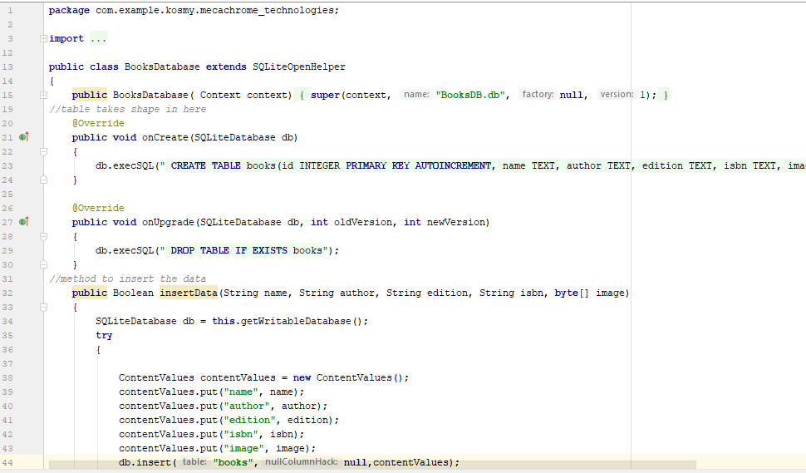

*Figure 38.1: Java file for BooksDatabase*



*Figure 38.2: Java file for BooksDatabase*

In conclusion, the mobile app created using the android platform allows the user to access some of the services that Roehampton University provides. In order to improve the app created, many other services can be added such as: renting a book from the library using the app, checking availability of books or booking them online. We could also add a "Useful information" page where more helpful information for students should be posted. Many other services can be added to the app created in order to improve it.

**References:**

[1] Android Developers. (2018). *Intent  |  Android Developers*. [online] Available at: https://developer.android.com/reference/android/content/Intent [Accessed 17 Nov. 2018].

[2] Examples Java Code Geeks. (2018). *ArrayList in Java Example – How to use arraylist*. [online] Available at: https://examples.javacodegeeks.com/core-java/util/arraylist/arraylist-in-java-example-how-to-use-arraylist/ [Accessed 28 Nov. 2018].

[3] View, C. (2018). *Custom Adapter for List View*. [online] Stack Overflow. Available at: https://stackoverflow.com/questions/8166497/custom-adapter-for-list-view?fbclid=IwAR1nB1trPTY1YrW9h3u_ECx5vOT01DsIAw1QPFiK-LkySwSQKykb3M6bRS4 [Accessed 1 Dec. 2018].

[4] www.javatpoint.com. (2018). *Java Constructor - Javatpoint*. [online] Available at: https://www.javatpoint.com/java-constructor?fbclid=IwAR1qMLptn4HsL8DCuTLMpj8fFh2pKGDG02Lecfn1DwQLYYy6NSrYaPt-QlQ [Accessed 10 Nov. 2018].

[5] www.tutorialspoint.com. (2018). *Java Encapsulation*. [online] Available at: https://www.tutorialspoint.com/java/java_encapsulation.htm?fbclid=IwAR0dR3yX_VQ5APOvxeKlDUKBqKP2SyBo0c48Eus6uaxk3KIJHReeJOPsm-c [Accessed 28 Nov. 2018].

[6] www.tutorialspoint.com. (2018). *Java The ArrayList Class*. [online] Available at: https://www.tutorialspoint.com/java/java_arraylist_class.htm?fbclid=IwAR2Zrh1M5MYhsmeXSMONczEhUIPPIBV9Tk2zNoEGn2KqIUtlj8tyVN-gAsI [Accessed 25 Nov. 2018].